INDIVIDUAL ASSIGNMENT
ACCOMMODATION MARKET PLACE
MOLEBOGENG RAMUSHU
241178630
PROJECT 2 (PRT262S)
MS. D.MATHIVHA
22 MAY 2025


TABLE OF CONTENTS
- Cover Page
- Project Title
- Student Name and Surname
- Student Number
- Module Name
- Supervisor
- Submission date

- Table of Contents

- Entity Relationship Diagram(ERD) Page 3
  - Introduction to the system
  - ERD Diagram
  - Explanation of Entities

- Attributes Data Page 8

- User Interface Design Page 10
  - Introduction
  - Screenshots / Interface Designs
  - Explanation of interfaces

- Business Rules Page 13

- Reflection Page 14

ENTITY RELATIONSHIP DIAGRAMS (ERD)
3.1. Introduction to the system
The UniNest Student Accommodation Marketplace System is designed to connect students looking for housing with landlords offering properties. The system provides a secure platform where users can register, log in, and access features based on their role. Students can search for available listings, make bookings, and leave reviews, while landlords can add and manage property listings, approve bookings, and track payments. The system ensures that all data is consistent through business rules and offers a user‑friendly interface to make navigation simple and efficient.

3.2. ERD DIAGRAM:

Full Project:
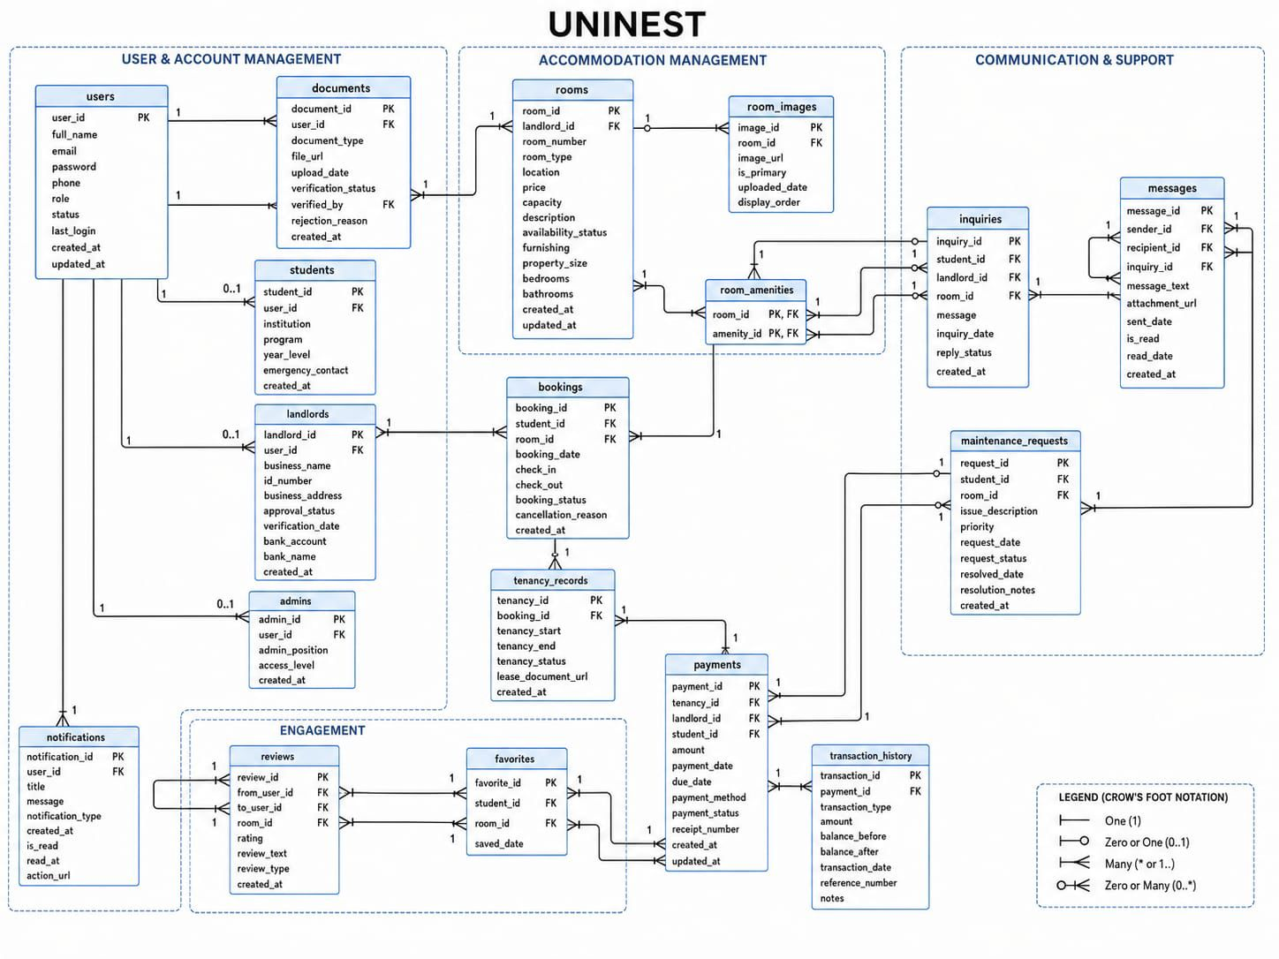

Landlord Subsystem:
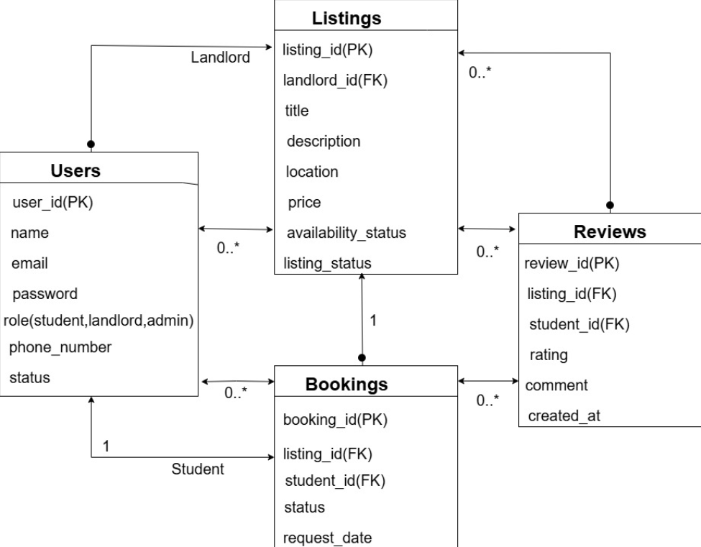
Users Listings 1:N
Listings Bookings 1:N
Listings Reviews 1:N
Users Bookings 1:N

3.3. Explanation of Entities:
- Users:
- Primary Key: user_id
- Attributes: name, email, password, role, phone_number, status
- Purpose: Stores account details for all system users. Landlords are identified here by their role.
- Relationship: One user : many listings and bookings.

- Listings:
- Primary Key: listing_id
- Foreign Key: landlord_id
- Attributes: title, description, location, price, availability_status
- Purpose: Represents properties listed by landlords.
- Relationship: One landlord : many listings. Each listing can receive many bookings and reviews.
(In the full UniNest ERD, properties are represented under the Rooms entity. In the Landlord Subsystem ERD that I did, this is shown as Listings because landlords mainly deal with posting and managing their property listings, so the term Listings fits better with their role in the system).

- Bookings:
- Primary Key: booking_id
- Foreign Keys: listing_id , student_id
- Attributes: status, request_date
- Purpose: Records students requests to reserve accomoodation.
- Relationship: Each listing can have many bookings; each student can have multiple bookings.

- Reviews:
- Primary Key: review_id
- Foreign Keys: listing_id, student_id
- Attributes: rating, comment, created_at
- Purpose: Stores feedback and ratings from students about properties and landlords.
- Relationship: Each listing can have multiple reviews; each student can submit reviews for booked properties.

- Users:
- Primary Key: user_id
- Attributes: full_name, email, password, phone, role, status
- Purpose: Stores login and identity information for all roles(students, landlords, admins).
- Relationship: One user can be linked to either a student profile or a landlord profile.

- Students:
- Primary Key: student_id
- Foreign Key: user_id
- Attributes: institution, program, year_level, emergency_contact
- Purpose: Holds specific data about students linked to their user account.
- Relationships: One student can make many bookings, payments, and reviews.

- Bookings:
- Primary Key: booking_id
- Foreign Keys: student_id, room_id (references Rooms/Listings)
- Attributes: booking_date, check_in, check_out, booking_status, cancellation_reason
- Purpose: Tracks accommodation reservations made by students.
- Relationships: Many bookings can be linked to one student and one room.

ATTRIBUTES DATA

Users Table
Attribute Name | Data Type | Size | Description
user_id | Integer | 5 | Unique identifier for each user
full_name | Text | 50 | User’s full name
email | Text | 100 | User’s email address
password | Text | 50 | User’s login password
phone | String | 15 | User’s contact number
role | String | 20 | Defines user type
status | string | 20 | Indicates if the account is active or suspended

Students Table
Attribute Name | Data Type | Size | Description
student_id | Integer | 5 | Unique student identifier
user_id | Integer | 5 | Foreign key linking to users table
institution | Tex | 100 | Name of the student’s institution
program | Text | 50 | Academic program enrolled
year_level | Integer | 2 | Year of study
emergency_contact | text | 15 | Student’s emergency contact number

Bookings Table
Attribute Name | Data Type | Size | Description
booking_id | Integer | 5 | Booking identifier
student_id | Integer | 5 | Foreign key linking to students table
listing_id | Integer | 5 | Foreign key linking to listings table
booking_date | Date | - | Date the booking was made
check_in | Date | - | Start date of stay
check_out | Date | - | End date of stay
booking_status | text | 20 | Indicates state of booking

Listings Table
Attribute Name | Data Type | Size | Description
listing_id | Integer | 5 | Identifier for each property listing
landlord_id | Integer | 5 | Foreign key linking to users table
title | Text | 50 | Listing title
description | Text | 200 | Details about the property
location | Text | 100 | Property location
price | Decimal | 10 | Monthly rental price
availability_status | text | 20 | Indicates if the property is available or booked

Reviews Table
Attribute Name | Data Type | Size | Description
review_id | Integer | 5 | Review identifier
listing_id | Integer | 5 | Foreign key linking to listings table
student_id | Integer | 5 | Foreign key linking to students table
rating | Integer | 1 | Rating score
comment | Text | 200 | Students feedback
created_at | date | - | Date review was submitted

USER INTERFACE DESIGN
5.1. Introduction:
The UniNest system interface was designed to be simple and easy to use for both students and landlords. Each page focuses on clear navigation and quick access to important features like property listings, booking requests, and messages. The layout uses familiar buttons, forms, and menus to make the system feel intuitive and professional, helping users complete tasks without confusion.

5.2. Screenshots / Interface Designs:

WIREFRAMES:
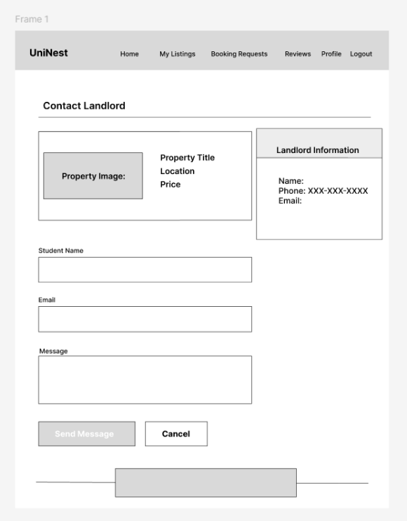

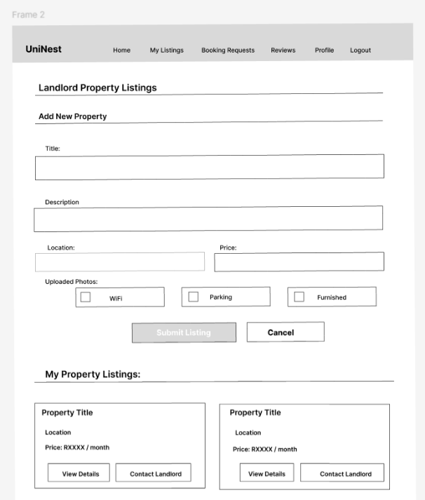

MOCKUPS:
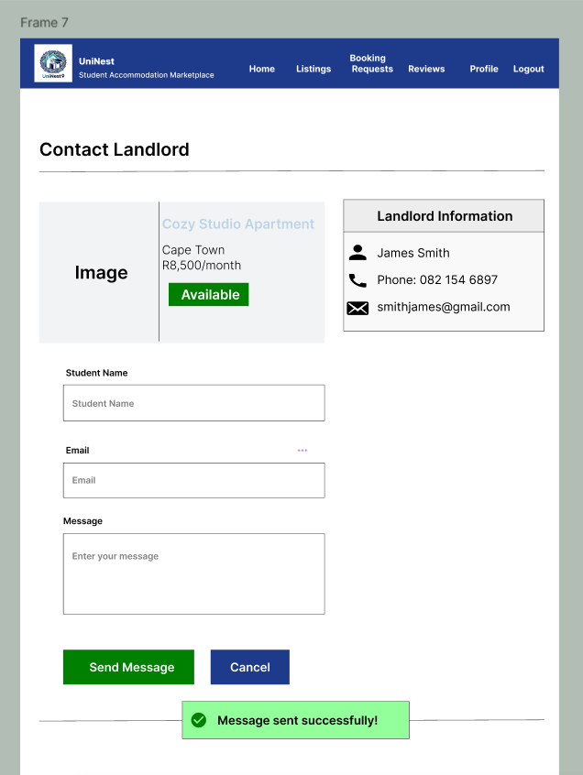

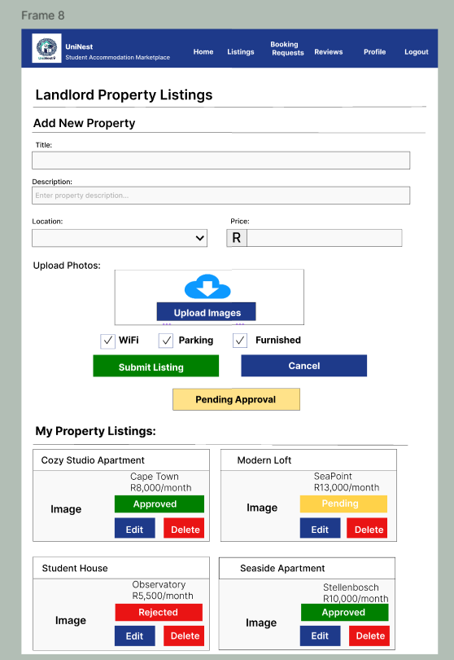

5.3. Explanation of Interfaces:
- Login Screen – Allows users to securely access the system using their credentials. It verifies roles(Student, Landlord, Admin) before redirecting to the correct dashboard.
- Main Menu – Acts as the central navigation bar for the UniNest system. It helps users move easily between pages such as Home, My Listings, Booking Requests, Reviews, and Profile. The menu stays visible on all screens, making it simple for both students and landlords to access different parts of the system quickly.
- Contact Landlord Page – Enables students to send messages directly to landlords. It includes landlord details, property information, and a message form with confirmation feedback (“Message sent successfully”).
- Landlord Property Listings – Lets landlords add, edit, and manage accommodation listings. It includes fields for title, description, location, price, and amenities, plus status indicators (Approved, Pending, Rejected).
- Report Screen – Summarizes property listings and booking statuses, helping landlords track performance and approvals.

BUSINESS RULES

The UniNest system follows these general rules to ensure consistency and accuracy:
- Unique Email Registration: Every user must register with a unique email address to avoid duplicate accounts.
- Login Requirement: Users must log in before they can access the system’s features.
- User Roles: Each user must have a defined role (Student, Landlord, or Admin) to control access and permissions.
- Responsible for rules on unique email registration, login requirement, and user roles. Attributes include user_id, email, and role. Relationships link Users to Students and Landlords.
- Mandatory Fields: All required fields must be completed before saving data (e.g., registration, listing creation, booking).
- Listings Approval: A property listing must be approved by an admin before it becomes visible to students.
- Responsible for rules on landlord ownership and admin approval. Attributes include listing_id, title, and location. Relationships connect Listings to Landlords, Bookings, and Reviews.
- Booking Rules:
- A booking can only be made for an approved listing.
- A student can have multiple bookings, but only one active booking per property.
- Responsible for rules on booking approval, status, and availability changes. Attributes include booking_id, check_in, and check_out. Relationships connect Bookings to Students and Listings.
- Payments: A payment record must be created once a booking is approved, and the amount must match the listing price.
- Responsible for rules on payment creation and amount validation. Attributes include payment_id, amount, and method. Relationships connect Payments to Bookings, Students, and Landlords
- Reviews:
- A review can only be submitted after a completed booking.
- Each student can submit only one review per listing.
- Reviews must include both a rating and a comment.
- Responsible for rules on review submission, uniqueness, and completeness. Attributes include review_id, rating, and comment. Relationships connect Reviews to Students and Listings.

REFLECTION

During this project, I learned how to design and document a system using ERDs, business rules, and user interface designs. I also gained a clearer understanding of how subsystems such as Users, Students, Listings, and Bookings connect together to form a complete application.
The main challenges I experienced were low activity on GitHub, technical issues, and procrastination. I struggled to stay consistent on GitHub, which affected my progress tracking. On top of that, my laptop crashed last week, and I had to wait for repairs before I could transfer my work and continue. This caused delays and made it harder to keep up with the group’s pace.
I solved these challenges by focusing on my allocated tasks and preparing my sections carefully so they could be integrated smoothly. Once my laptop was repaired, I organized my files and caught up with the work. I also made sure that during meetings; I contributed clearly to balance out my limited communication outside of them.
Through the project, I gained skills in structured documentation, ERD design, writing business rules, and explaining technical concepts in a simple way. I also developed resilience in handling technical setbacks and learned the importance of consistent collaboration tools like GitHub.
In future projects, I would improve by communicating more regularly with my team outside of meetings, engaging more actively on GitHub, and preparing backup options in case of technical problems. I would also try to work on future assignments early and not put them aside and let procrastination get the best of me. This would make collaboration smoother, reduce delays, and ensure that my contributions are integrated earlier and submission is done without pressure.

